Swaziland

## Freedom House political status

The data set shows the Freedom House political scores and status of the country each year.

## # A tibble: 19 x 5  
## country iso3c date mean status   
## <chr> <chr> <dbl> <dbl> <chr>   
## 1 Swaziland SWZ 1996 5.5 Not Free  
## 2 Swaziland SWZ 1998 5 Not Free  
## 3 Swaziland SWZ 2000 5.5 Not Free  
## 4 Swaziland SWZ 2002 5.5 Not Free  
## 5 Swaziland SWZ 2003 6 Not Free  
## 6 Swaziland SWZ 2004 6 Not Free  
## 7 Swaziland SWZ 2005 6 Not Free  
## 8 Swaziland SWZ 2006 6 Not Free  
## 9 Swaziland SWZ 2007 6 Not Free  
## 10 Swaziland SWZ 2008 6 Not Free  
## 11 Swaziland SWZ 2009 6 Not Free  
## 12 Swaziland SWZ 2010 6 Not Free  
## 13 Swaziland SWZ 2011 6 Not Free  
## 14 Swaziland SWZ 2012 6 Not Free  
## 15 Swaziland SWZ 2013 6 Not Free  
## 16 Swaziland SWZ 2014 6 Not Free  
## 17 Swaziland SWZ 2015 6 Not Free  
## 18 Swaziland SWZ 2016 6 Not Free  
## 19 Swaziland SWZ 2017 6.5 Not Free

## Freedom House classification of political change

The data set shows the GDP growth and the ecomic growth classification of the country each year.

## # A tibble: 19 x 4  
## country iso3c date politicalChangeFH  
## <chr> <chr> <dbl> <chr>   
## 1 Swaziland SWZ 1996 no change   
## 2 Swaziland SWZ 1998 democratization   
## 3 Swaziland SWZ 2000 no change   
## 4 Swaziland SWZ 2002 no change   
## 5 Swaziland SWZ 2003 autocratization   
## 6 Swaziland SWZ 2004 no change   
## 7 Swaziland SWZ 2005 no change   
## 8 Swaziland SWZ 2006 no change   
## 9 Swaziland SWZ 2007 no change   
## 10 Swaziland SWZ 2008 no change   
## 11 Swaziland SWZ 2009 no change   
## 12 Swaziland SWZ 2010 no change   
## 13 Swaziland SWZ 2011 no change   
## 14 Swaziland SWZ 2012 no change   
## 15 Swaziland SWZ 2013 no change   
## 16 Swaziland SWZ 2014 no change   
## 17 Swaziland SWZ 2015 no change   
## 18 Swaziland SWZ 2016 no change   
## 19 Swaziland SWZ 2017 autocratization

## Freedom House score trend

The plot shows the Freedom House scores trend of the country.

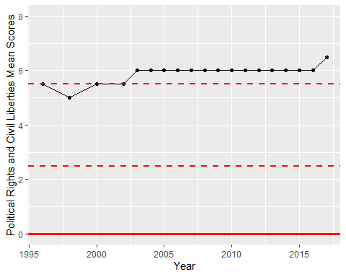

Freedom House Score Trend